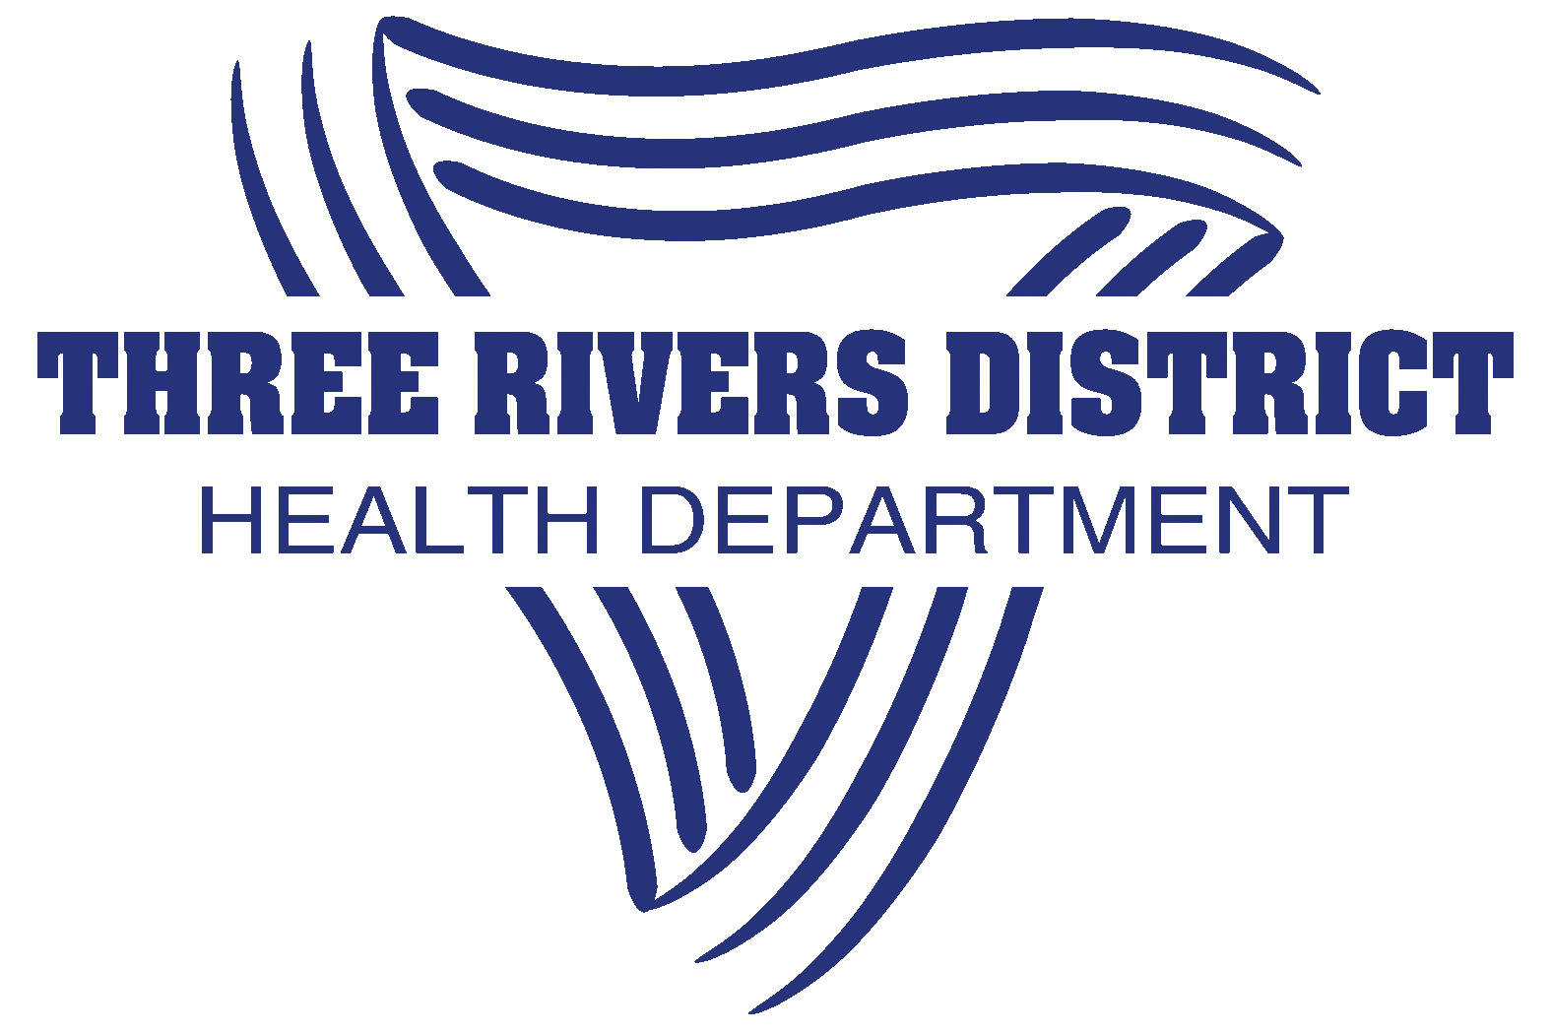
Three Rivers District Health Department is recruiting a self-motivated, energetic, passionate individual to fill an opening for our Accreditation Coordinator position.

General Duties: Effectively coordinates and develops documentation for public health accreditation and re‐accreditation measures and objectives. Maintains required agency documentation with the Public Health Accreditation Board including registration, application materials, documents, and annual reports. Monitors and tracks progress of the agency as well as projects aimed at addressing gaps in measure documentation. Develops plans, processes, and policies necessary to achieve public health accreditation goals and objectives for the agency.
Preferred Education, Training or Experience: Degree from an accredited college or university. Position is relevant to (but not limited to) those with various education and/or work experience in Community/Economic Development, Public Policy, Public Relations, Marketing, or Public Health. Must be able to travel throughout the four-county district area, as well as attend trainings in and out of state. (Job related travel costs are reimbursed/provided by the agency)
Starting salary: Salary is commensurate with education and experience. Excellent fringe benefits including state pension, and many opportunities for growth.

Applications: Contact Three Rivers District Health Department, 60 Old Monterey Rd, Owenton, KY 40359, (502) 484-3412 or www.trdhd.com/jobs
Equal Opportunity Employer

