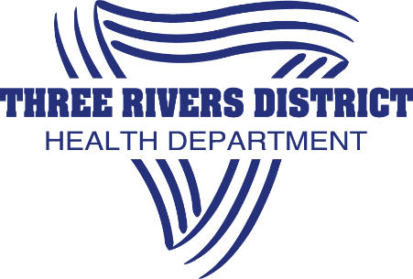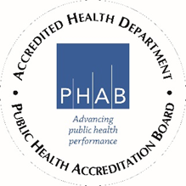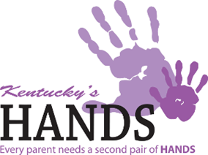
Mission: Striving for excellence, educating and empowering with every encounter.
Vision: All One Team!
Values: We are Advocates, Collaborators and Leaders.
Community Health Strategist

HANDS NURSE/SOCIAL WORKER

Title: HANDS Nurse/Social Worker
Location: Owen County
Salary is commensurate with education and experience.
Connect Your Passion with Our Purpose
If you are a nurse or social worker looking for a career that offers work-life balance, professional development, and the chance to contribute to the health of your community, then look no further. Three Rivers District Health Department has an immediate opportunity for you to join our dedicated and mission-driven team.
Qualified candidates will be a Licensed Registered Nurse or Social Worker.
The Kentucky Health Access Nurturing Development Services (HANDS) program is a voluntary home visitation program for any new or expectant parents. HANDS supports families as they build healthy, safe environments for the optimal growth and development of children. HANDS supports parents throughout the pregnancy and the first two years of the baby’s life. From pregnancy to the terrific twos, HANDS is here to answer all questions during the different stages of baby’s growth. Families meet with a HANDS parent visitor who can answer questions and address concerns about pregnancy or baby's first years. All families receive information and learn about resources available in the community for new parents. Some families receive further support through home visitation. That’s right. Information is brought right to the home.
This position serves under the direction of the HANDS Manager or other supervisor assigned. Responsibilities for this position include, but are not limited to:
- Conducting home visits with HANDS participants to assist with child development, parenting skills, health services and other needed resources.
- Making referrals to community resources.
- Tracking appointments, completing follow-up visits, and performing evaluations of client needs.
- Preparing and maintaining case records with the necessary confidentiality.
- Working with the HANDS Manager, supervisor, and peers to collaborate on case management.

Applicants must be at least 18 years of age and possess a valid driver’s license and telephone accessibility. The following on-the-job training will be a requirement within 6 months of hire to advance:
- HANDS Home Visitor Core Training
- HANDS Wrap-Around Training
- CPR certification
- Working knowledge of the geographical area and/or the ability to locate participants and community resources with use of maps, contacts, and directions provided.
Three Rivers District Health Department is committed to diversity, inclusion, equity, and providing a welcoming environment. We also offer:
- Comprehensive benefits package, including accrual of vacation and sick days and 11.5 paid holidays; medical insurance, and optional dental, and vision coverage; life insurance.
- Training, development, and promotional opportunities
- Flexible work hours; 37.5-hour work week with occasional weekend assignments. Full time, usual hours 8:00 a.m.–4:30 p.m., M–F, including lunch break. Hours may vary depending on events that are taking place; community events may be held in the evenings and on weekends.
- Paid overtime
- A guaranteed pension plan via KPPA Retirement System
- Opportunities for Public Service Loan Forgiveness program for eligible workers
- Commitment to diversity, inclusion, equity, and a welcoming environment. Affirmative action commitment.
Please note: This posting is not meant to be an all-inclusive list. It presents highlights of the position’s scope and function and the candidates’ requirements and rewards.
Application Instructions:
- Apply via Indeed or https://trdhd.com/jobs/
- Three Rivers District Health Department is committed to the full inclusion of all qualified individuals. In keeping with our commitment, Three Rivers District Health Department will take the steps to ensure that people with disabilities are provided reasonable accommodations. Accordingly, if reasonable accommodation is required to fully participate in the job application or interview process, to perform the essential functions of the position, and/or to receive all other benefits and privileges of employment, please contact Sherry Fitzgerald (502) 484-3412.

